SalesKik – Master Blueprint
Generated: 2025-08-11 06:59
This document includes the high-level mud map and the full programming brief for Claude Code.
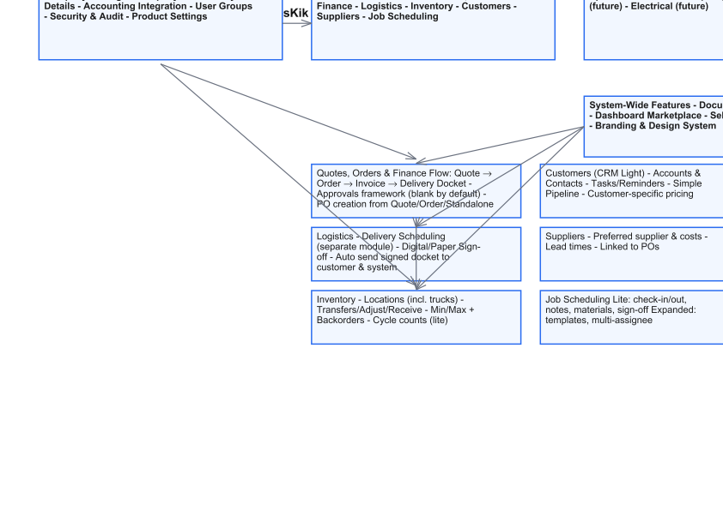

Purpose of this Document
------------------------
This blueprint defines the functional and UX design for SalesKik. It is written for developers (Claude Code) to implement a modular, self-service business platform for small to medium teams. All modules work standalone, can be enabled/disabled from a dashboard marketplace, and emphasise simplicity over enterprise complexity.

Design Principles (Non-Negotiable)
----------------------------------
• SME-first: built for 2–40 person teams; no enterprise complexity.
• Self-service: customers enable modules, run wizards, and configure without help.
• Simple UI: minimal fields per screen, progressive disclosure, mobile-friendly.
• Clear dependencies: modules advertise what they require before enabling.
• Blank-by-default rules: approvals and constraints are optional; nothing enforced until configured.
• Strong audit trail (lightweight): who/what/when; no heavy content logging by default.
• Documents: flexible output controls to hide/show details per customer and per send.
• History-safe: edits never rewrite historic docs; versioning everywhere it matters.
• Security: role-based permissions via User Groups; invitations + re-invite; optional 2FA later.

1) Company Settings
-------------------
A. Company Profile & General Settings
- Logo upload with auto-resize for documents.
- Business name, ABN/ACN, GST, address, email, phone.
- Start with one location; add more later.

B. Payment Details (with Accounting Link)
- Multiple payment profiles (e.g., Retail Prepay, Trade 30 EOM).
- Methods: cash, cheque, EFTPOS, bank transfer, credit cards.
- Custom notes per profile shown on invoices.
- This area also hosts accounting integration linking.

C. Accounting Integration
- Connect to Xero/MYOB; map sales/purchase/credit codes.
- Import numbering sequences; set invoice/order/credit prefixes.
- Tax rules (GST etc.).

D. User Groups
- Multi-group membership; union of permissions.
- Full permissions matrix across the system.
- Invitations & Access: invite by email, re-invite, self-reset, pending panel.

E. Security & Audit
- Light user activity history: sign-ins, C/U/D on key objects, exports.
- 12-month retention by default (configurable). Write-once logs.

F. Product Settings
- Category → Subcategory → Product Type; multi-category mapping for one SKU.
- Bulk upload via template spreadsheet; inline error fixing.
- Single-item entry with a modern, card-style form.
- SKU management: manual entry or auto-generate (CAT-SUB-####).
- AI SKU pattern learning; suggestions only; per-company memory.
- Pricing: cost, weight, price lists (blank by default), margin floor rule (optional).
- Defaults: cost+markup by list (checkbox), rounding rules, effective dating.
- Packages/kits; inventory deduction by components; optional own price.
- Formula pricing: sqm/lm/perimeter/weight; visual editor; templates.
- Template Builder (future module) noted.
- Safe archive and version history; rename vs replace rules.

2) Quotes, Orders & Finance (Core Module)
-----------------------------------------
A. Quotes
- Workflow modes: Simple, Drafts, Approval Required (framework only; blank by default).
- States: Draft → Pending approval → Approved → Sent → Viewed → Accepted/Declined → Expired.
- Content: customer/contact, addresses, items from catalogue/templates, manual lines (if allowed).
- Pricing: pulls customer price list and overrides; margin floor warnings if enabled.
- Acceptance: e-sign, reply-to-accept, SMS code, or signed PDF upload.
- Numbering & revisions from Accounting Integration (Rev A/B/C).
- Document Output Controls at send-time; per-customer defaults optional.
- Copy/Variant tools: copy to same/different customer; variant builder to swap attributes (e.g., glass type) and reprice.

B. Orders
- Convert accepted quote to order; or create order directly.
- Revisions tracked; reason required for edits to confirmed orders.
- Allocation: reserves stock; creates backorders if short.
- Purchase Orders: create from quote, order, or standalone. Supplier pricing, receipts, returns, landed cost, and invoice matching included.

C. Finance (Invoices & Payments)
- Invoice types: deposit, progress, final; credit notes linked to source invoice.
- Sync to accounting; option to post as draft.
- Edit/delete allowed with permission + sign-off; full audit with before/after.
- Payment recording; multi-method allocations; two-way sync of paid status.
- Delivery Docket generated post-invoice with digital/paper sign-off storage.

3) Logistics (Module)
---------------------
A. Delivery Scheduling (module scope; simple SME version)
- Create delivery from order or ad-hoc job.
- Assign driver + vehicle; optional time window.
- Driver mobile app: tick items, capture signature/photo proof.
- On digital sign-off: attach PDF to order/invoice and email customer automatically.
- Paper option: scan/upload later.

B. Stock Movement (links with Inventory)
- Transfers between locations (including trucks).
- Simple reasons; optional approval for large moves.

4) Inventory (Module)
---------------------
- Stock overview per location; search by SKU/name/category.
- Item detail: cost, price lists, supplier, stock by location.
- Transfers, Adjustments (reasons), Receiving tied to POs.
- Allocations/backorders; one-click fulfil when stock lands.
- Cycle counts: ad-hoc or by category; approve variances → adjustments.
- Min/Max levels; Suggest PO; alerts.
- Packages deduct components; pre-assemble option.
- Returns: customer and supplier; write-offs with reasons.
- History: per-SKU and global logs; CSV export.
- Permissions: simple roles for view/transfer/adjust/receive/config.

5) Customers (CRM Light)
------------------------
- Accounts & Contacts; quick add on mobile; business card scan option.
- Price list assignment; customer-specific overrides.
- Activity timeline: quotes, orders, invoices, deliveries, payments.
- Tasks/reminders; Today on road view; check-in/out (with GPS module).
- Simple pipeline (stages are configurable); convert to account + quote.
- Segments for light marketing; CSV export or simple email; opt-out respected.
- Permissions for view/edit/pricing/export.

6) Suppliers (Module)
---------------------
- Supplier records with contacts, lead times, preferred status.
- Price lists/cost history per SKU; last cost shown on POs.
- Linked to Purchase Orders and receipts; documents stored.

7) Job Scheduling (Module)
--------------------------
Lite (for tradies/sole traders)
- New job: customer, address, notes, target date; assign 1 person.
- Calendar/list views; drag to reschedule.
- On-site: Arrived (photo timestamp), optional GPS; timer auto-start/stop.
- Notes/checklist/materials (deduct stock); issues with photo.
- Sign-off digital or paper; PDF attaches; draft invoice from materials + labour.

Expanded (SME)
- Recurring jobs, multi-assignee, templates, timesheet exports, customer notifications.

8) Special Module: Glass
------------------------
- Types and thicknesses with sqm base rates; supplier links and lead times.
- Processing add-ons: holes, cutouts, edge work, corners, specials; rules for limits.
- Coatings (e.g., ClearShield) applied to all or selected items at any stage.
- Formula engine for sqm/perimeter/weight; dimensions in mm/inches.
- Smart defaults: auto add polish on new panel (company/template/customer level).
- Bulk apply at end (e.g., add coating to all selected items) with preview and undo.
- Inventory/Purchasing: standard sizes can draw stock; custom panels ordered via PO with drawings.
- Document outputs: per-panel vs summary-only; processing hidden or shown.

9) System-Wide: Document Output Controls
----------------------------------------
- Per-doc toggles: show totals only, show/hide line prices, descriptions, package breakdown, processing details, payment details, discounts, addresses, tax visibility.
- Per-customer defaults (presentation profile) + presets library.
- Generate & Preview PDF; email/send/print; history/tracking.
- Compliance: watermarks (DRAFT/REVISED/PAID), revision labels, ABN/GST footer.
- Safety rails: explain when a toggle is blocked by company policy; audit stamp of choices.

10) Dashboard & Module Marketplace
----------------------------------
- Login lands on Dashboard with modules grid: enable/disable with clear prices and dependencies.
- Setup wizards: 1–3 minutes, skip optional steps; tooltips and short videos.
- Clear “what’s next” after enabling (e.g., create your first quote).
- Billing: monthly cycles, cancel anytime; dependencies explained before checkout.

11) Permissions & Security (Glue)
---------------------------------
- User Groups with union-of-permissions; matrix across modules.
- Invitations & Access: invite/re-invite/self-reset; link expiry; basic password policy.
- Optional 2FA later; device alerts.
- User Activity History (light): who/what/when, module, object ref; CSV export.

Implementation Notes for Developers
-----------------------------------
• Keep screens uncluttered; use collapsible 'Advanced' sections.
• Autosave forms and protect against duplicate submissions.
• Maintain strict versioning for products, prices, quotes, orders, invoices.
• Respect “blank-by-default” rules: no approvals or thresholds active until configured.
• Provide clean API endpoints for each module for future integrations.
• Ensure all generated numbers (quotes/orders/invoices/POs/dockets) respect Accounting Integration settings.
• All features should degrade gracefully if linked modules are not enabled.

